GitHub – Branching and Merging

T Godwin Abilash – 192321012

**5**. Branching and Merging

Question:

In your GitHub repository, create a new branch called feature-login. Implement a simple login function in a login.py file. After completing the function, create a pull request to merge feature-login into the main branch.

Tasks:

Create a new branch feature-login.

Add a login.py file with a simple login function.

Commit the changes and push them to GitHub.

Create a pull request from feature-login to main and merge it.

**Set Up Git**

* Install [Git](https://git-scm.com/downloads) on your system if not already installed.
* Configure Git with your username and email:

git config --global user.name "Your Name"

git config --global user.email "youremail@example.com"

git init

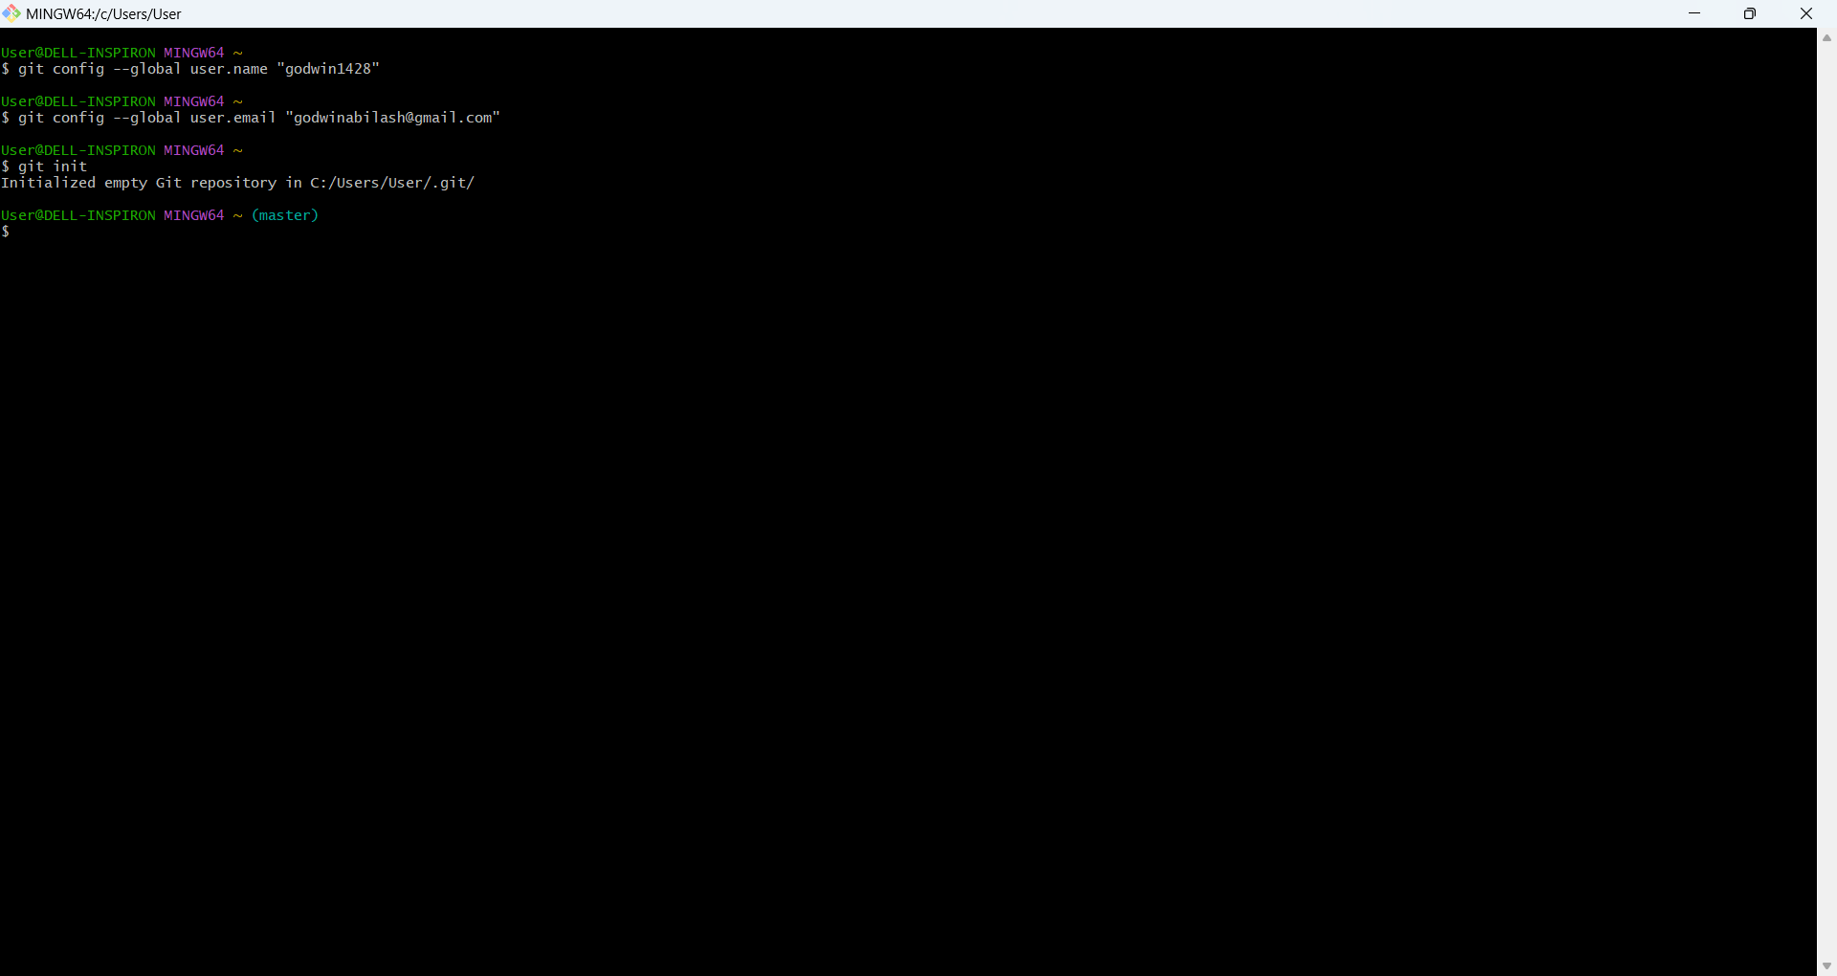

1. Create a New Branch: feature-login

1. Navigate to your local repository in the terminal:

cd /path/to/your/repository

1. Create and switch to a new branch:

git checkout -b feature-login

* + checkout -b: Creates and switches to the new branch.

2. Add a login.py File with a Simple Login Function

1. Create a new file named login.py:

nano login.py

1. Implement a simple login function.
2. Save and close the file.

3. Commit the Changes

1. Stage the new file:

git add login.py

1. Commit the changes with a message:

git commit -m "Add login function in login.py"

4. Push the feature-login Branch to GitHub

1. Push the branch to GitHub:

git push origin feature-login

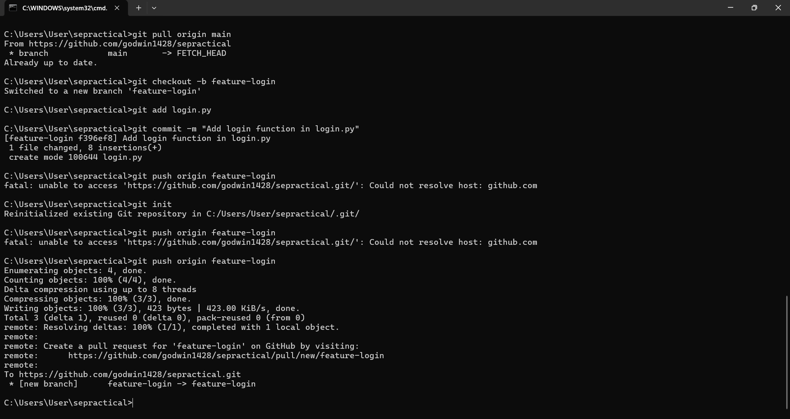

5. Create a Pull Request (PR)

1. Go to your repository on GitHub.
2. You'll see a prompt to create a pull request for feature-login. Click "Compare & pull request".
3. Add a description for your PR (e.g., "Implemented a simple login function").
4. Click "Create pull request".

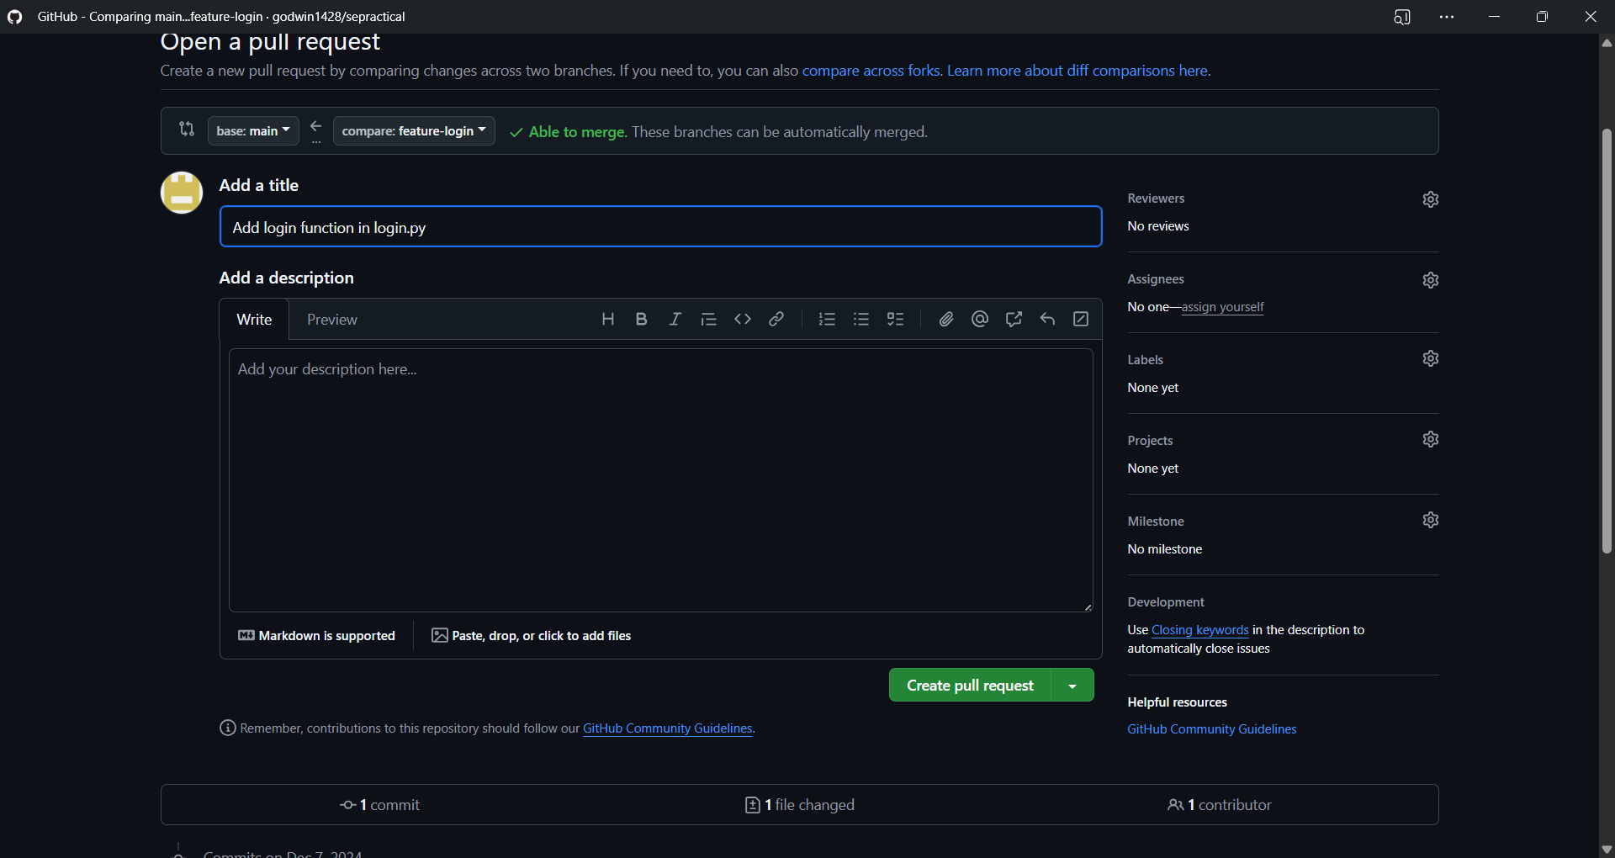

6. Merge the Pull Request

1. On the PR page, click "Merge pull request".
2. Confirm the merge by clicking "Confirm merge".
3. (Optional) Delete the feature-login branch on GitHub.

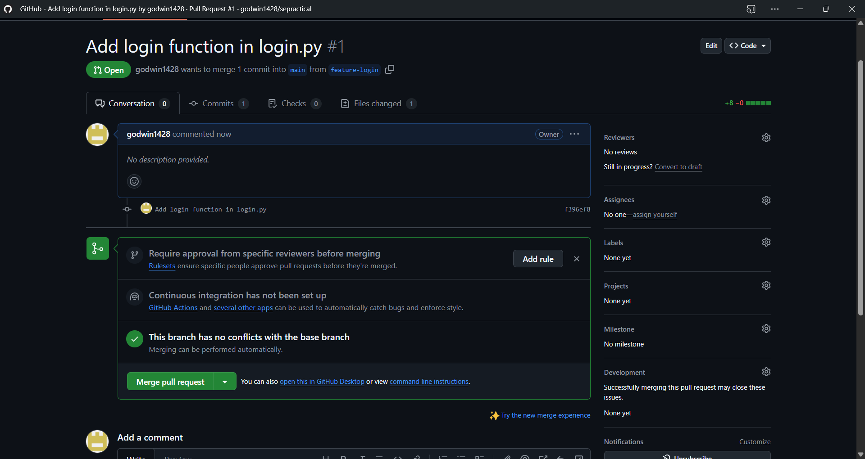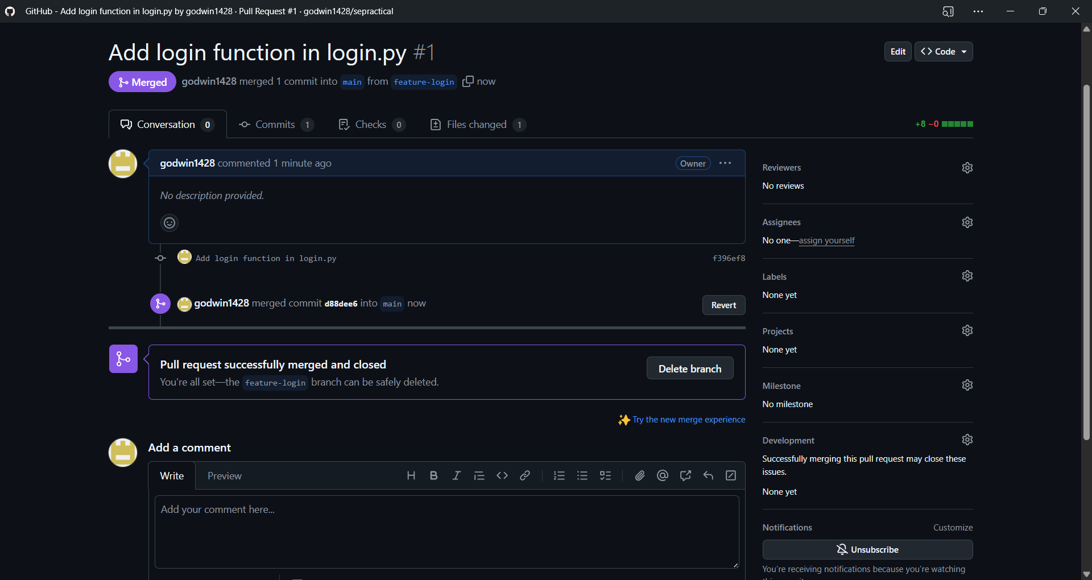

7. Update Your Local Main Branch

1. Switch back to the main branch locally:

git checkout main

1. Pull the latest changes from GitHub:

git pull origin main

